Naam/Namen: ……………………….………………………..…….. Datum: ………………….. Titel proef: …………………………………………………..….
Onderzoeksvraag:
Wat is de massa van het karretje? Bepaal op decigrammen nauwkeurig.
Theorie/formules:
……………………………………………………………………………………………….……………………………………………………………………………………………….……………………………………………………………………………………………….…………………………………………………………………………………..…………….…………………………………………………………………………………………………………………………………………………………………………………………………………………… ……………………………………………………….……………………………………………………………………………………………….……………………………………………………………………………………………….…………………………………………………………………………………..…………….……………………………………………………………………………………………………………………………………………………………………………

Grootheden
Onafhankelijke variabele: …………………………..…
Afhankelijke variabele: ………………………………..
Gecontroleerde variabele(n): ………………………... ……………………………………………………………

Procedure:
1……………………………………………………………………………………………….……….………………
2……………………………………………………………………………………………….……….………………
3……………………………………………………………………………………………….……….………………
4………………………………………………………………………………………………..……….……………..
5………………………………………………………………………………………………..……….……………..
6………………………………………………………………………………………………..……….…………….
7………………………………………………………………………………………………..……….…………….
8………………………………………………………………………………………………..……….…………….

Opstelling:

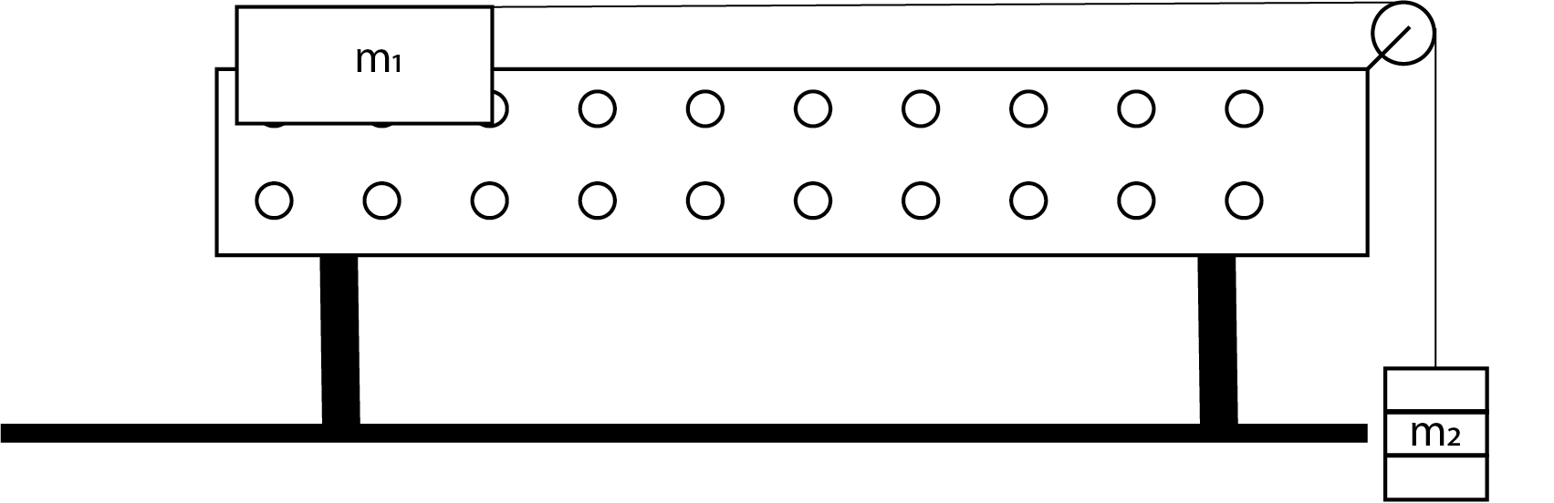

Materialen:
* Airtrack met karretje met onbekende massa
* Stopwatch
* Accelerometer
* Verschillende massa’s m₂
*…………………………………………………………………
*…………………………………………………………………
*…………………………………………………………………
*…………………………………………………………………

Aantekeningen en opmerkingen
Conclusie(s):
……………………………………………………………………………………………….………………………………………………………………………………………………………..……………………………………………………………………………………………….……………………………………………………………………………………………………………….………………………………………………………………………………………….……………………………………………………………………………………………………………………………………….……………………………………………………………………………………………………………………………………….……………………………………………………………………………………………………………………………………….……………………………………………………………………………………………………………………………………..
Wat ik nog zeggen wilde:
………………………………………………………………………………………………………………………………………………………………………………………………………………………………………………………………………………………………………………………………………………………………………………………………………………………………………………………………………………………………………………………………………………………………………………………………………………………………
Over nauwkeurigheid en precisie:
………………………………………………………………………….………………………………………………………………………….………………………………………………………………………….…………………………………………………….……………………………………………………………………………………………….………………………………………………………………………….………………………………………………………………………….……………………………………………………………………………………………………………………..
Analyse & trend:
……………………………………………………………………………………………………………………………………………………………………………………………………………………………………………………………………………………………………………………………………………………………………………………………………………………………………………………………………………………………………………………………………………………………………………………………………………………………………………………………………………………………………………………………………
Grafieken:

Observaties, metingen en berekeningen:
…………………………………………………………………….………………………………………………………………………………………………………………………………………………………………….……………………………………………………………………….………………………………………………………………………………………………………………………………………………………………….……………………………………………………………………….………………………………………………………………………………………………………………………………………………………………….…………………………………………………………………

